KOMAL-AN INSPIRATION FOR ALL
“Let us remember: one book, one pen, one child and one teacher can change the world. “
-MalalaYousafzai

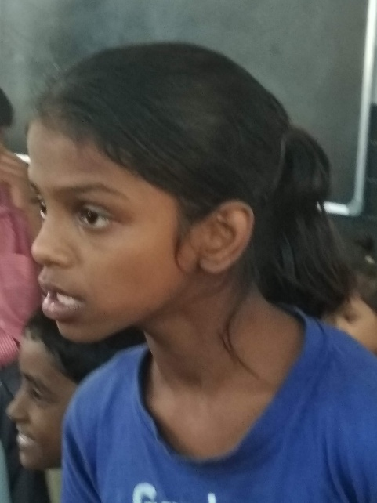
DRCSC is working in a school namely ‘Garden for Children’ for last one year. The school is situated at proper South Kolkata (ward no 85). Among the 25 schools, the school teachers of this school are very much empathetic as well as much more responsible than many others.
KomalPrajapati is an especially able child, who is studying in class III of this school. She started her earliest education from the school. Her father’s name is ShriRambabuPrajapati and mother is Smt. GuriaPrajapati. She lives at 22, Garcha Lane, Kolkata- 700 019 with one elder sister and two younger brothers and with parents.
When she started her first school education, she was little bit aggressive in nature. Sometimes she bitten others if something was not in her favor. There was much more problems regarding the acceptance of Komal in the day to day class room situation by the other school mates. After spotting the situations the teachers discussed the matter in prayer-assembly and also initiated individual interaction.
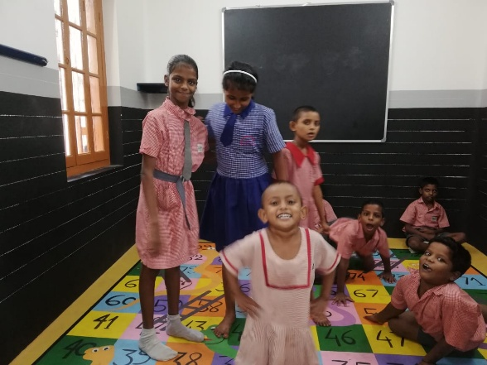
Then she started to involve herself in the daily activities under the supervision of teachers. As a result, slowly she got the acceptance among the school mates. Once a time, she acquired enough confidence and she began to participate in different contest with other pupil. A few days later, surprisingly she started to answer more difficult questions. The teachers also astonished a different Komal. She was trying to develop herself leaving her mental and physical challenges far behind. It could be playground or stage for some cultural event or classroom, she was an active participant. Recently, she performed in a drama in school’s annual cultural programme without any hesitation. .
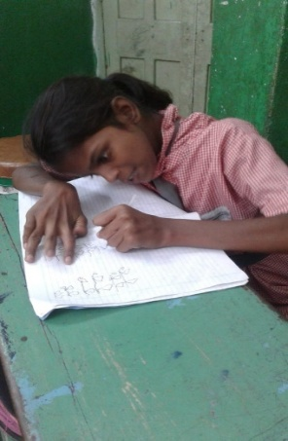
Now she is much more matured, active, responsible student of this school. The special educator of the circle(circle no – XI) had contributed a lot for her development. The school authority has discussed openly in the meetings with the other guardians like SDC (School Development Committee) and MTA (Mother teacher association) etc. The guardians also became empathetic towards her. She is a perfect example of ‘inclusive education’, who is trying to overcome all problems with smiling face. As if she just always ready to catch any offer for her future growth.
We are hoping for betterment in every aspects of life in her own ways. She will be an example for all of us who are getting tired after facing day to day challenges in our lives. If DRCSC’s contribution towards her development will increase her quality of living, then we will feel much more happy and grateful.

